**Lesson plan: Ecological niche modelling (species distribution modelling) in R**

Instructor: Dr. Katharine Marske, University of Oklahoma

Teaching Assistants: Michelle Busch & Emanuell Duarte Ribeiro, University of Oklahoma

2 days, 2.5 hours/day

**Before class/getting set up:**

Install R studio: <https://rstudio.com/products/rstudio/download/>

Install Java and rJava and make sure they are running.

Once your R libraries are installed, copy/paste the Maxent program files from the Comp Sci Workshop > Maxent folder into the dismo > java folder

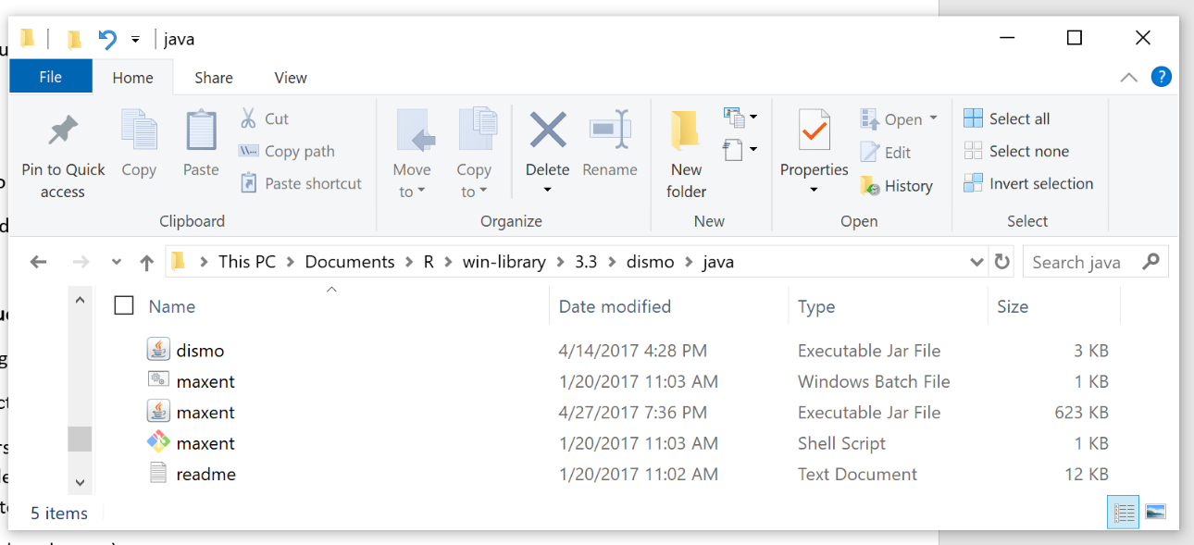

**Day 1: Introduction to species’ ranges, the ecological niche, and Species Distribution Models**

Key ideas: biogeography, species range (or distribution), ecological niche

Learning objectives:

* Understand the abiotic and biotic factors which affect where (geographically) species occur
* Be able to describe the relationship between a species’ range and its ecological niche
* Execute simple R commands to build a Species Distribution Model using the R package dismo

Introduction (short lecture):

* What is the ecological niche?
* What is an ecological niche model/species distribution model?
* How are SDMs useful?
* Brief introduction to our study system, the beetle fauna of New Zealand

Code along with me:

* Brief introduction to R
* Importing and mapping climate and species occurrence data
* Building your SDM by calling Maxent through the R package dismo
* Validating your SDM
* Projecting your model into geographical space

To take notes within the R code, precede each line with # and R will ignore it when you run the code.

Optional extra: making attractive maps in R with color schemes from colorbrewer2.org

**Day 2: SDMs, climate change and genetic diversity of New Zealand beetles**

Key ideas: glacial refugia, species richness, genetic diversity

Learning objectives:

* Understand the relationship between long-term climatic stability and genetic diversity
* Using the code from yesterday, build a SDM for at least one New Zealand beetle species, mapping its potential geographic distributions for current, LGM and 2050 climate conditions
* Use your SDM results to identify candidate areas for conserving genetic diversity for New Zealand beetles

Introduction (short lecture):

* What are glacial refugia?
* What do glacial refugia have to do with the distribution of genetic diversity?
* How will species respond to current climate change?

Assignment: Prepare a single power point slide with LGM, current and future maps for your species, indicating where you think would be the best region for preserving genetic diversity.

Modify yesterday’s code to build an SDM for at least one species to answer the following questions:

1. Based on the location(s) of glacial refugia for your species, where within its current range do you expect to find the highest genetic diversity?
2. Will these high-diversity areas continue to be within the species' range in 2050?
3. Will any of the species current range remain suitable in 2050, or will the species have to move to reach suitable habitat?

Optional extras:

* Generate SDMs for additional species to determine whether these species shared refugia in the past and will respond similarly to contemporary climate change
* Use the code for a General Linear Model (GLM, bottom of the R code page) to build an SDM. How do the resulting maps compare to those you generated with Maxent?

**Quick Reference: “Bioclimatic” variables**

BIO1 = Annual Mean Temperature  
BIO2 = Mean Diurnal Range (Mean of monthly (max temp - min temp))  
BIO3 = Isothermality (BIO2/BIO7) (* 100)  
BIO4 = Temperature Seasonality (standard deviation *100)  
BIO5 = Max Temperature of Warmest Month  
BIO6 = Min Temperature of Coldest Month  
BIO7 = Temperature Annual Range (BIO5-BIO6)  
BIO8 = Mean Temperature of Wettest Quarter  
BIO9 = Mean Temperature of Driest Quarter  
BIO10 = Mean Temperature of Warmest Quarter  
BIO11 = Mean Temperature of Coldest Quarter  
BIO12 = Annual Precipitation  
BIO13 = Precipitation of Wettest Month  
BIO14 = Precipitation of Driest Month  
BIO15 = Precipitation Seasonality (Coefficient of Variation)  
BIO16 = Precipitation of Wettest Quarter  
BIO17 = Precipitation of Driest Quarter  
BIO18 = Precipitation of Warmest Quarter  
BIO19 = Precipitation of Coldest Quarter

**Troubleshooting:**

-Are you in the correct directory? getwd() tells you where you are. The list() function lists the files in your current location.

-The View() function: does the R object you just created look like what you expected?

-Map using the plot() function: did your localities or climate layers load ok?

-Capitalizations, punctuation errors, misspelled filenames: these are the most common types of mistake.

-Java and RJava (necessary to run Maxent):

Getting RJava functioning on your computer can be a challenge. Without being able to help you in person, there may be a few of you for whom we are unable to get RJava set up correctly.

In case we cannot get RJava working on your computer, I have generated results for all four species, which are available in the folder aptly named Backup_Plan. All files generated by R have filenames starting with “Rmaxent_”. All other files are generated by the Maxent software. This way, you can at least follow along and see the results everyone else is seeing.

I have also included code for an SDM which used a General Linear Model instead of Maxent—the code for that is at the very bottom of the R code provided. You will not be able to do the k-folds cross-validation or estimate the importance of the different climate predictors, but you will be able to generate maps of your species’ distribution for the three different time periods.